
FT/MAQP/1221/B 23-SEP-2021
FIRST TERM EXAMINATION (2021-22)
Subject: MATHEMATICS  Grade: 12 |  |  |  | Max. Marks:40  Time:90 minutes
Name: |  |  |  |  |  |  | Section: | Roll No:
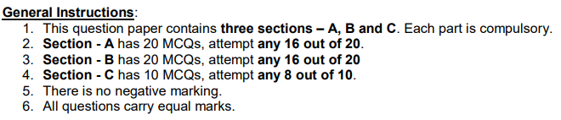.
Section – A
In this section, attempt any 16 questions out of 1 – 20.
Each Question is of 1 mark weightage.
 | If A={a,b,c} and B = {4,5,6}, then the number of functions from A to B is
 | a. | 9 |  |  | b. |  | 27
 | c. | 18 |  |  | d. |  | 18
2. | An optimization problem may involve finding:
 | a. | Maximum profit |  |  | b. |  | Minimum cost
 | c. | Minimum use of resources |  |  | d. |  | All of the above
3. | Which of the following corresponds to the principal value branch of ?
 | a. | 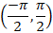 |  |  | b. |  | 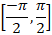
 | c. | 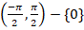 |  |  | d.
4. | If two matrices A and B are of order & respectively, can be subtracted only if
 | a. | p = q |  |  | b. |  | p = q, r = s
 | c. | P = r, q = s |  |  | d. |  | - None of these
5. | For the set A = {1,2,3}, define a relation R in the set A as follows  R = {(1,1), (2,2), (3,3) , (1,3)}. Then the ordered pair to be added to r to make it the smallest equivalence relation is:
 | a. | (1,3) |  |  | b. |  | (3,1)
 | c. | (2,1) |  |  | d. |  | (1,2)
6. | If 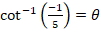 , the value of is:
 | a. |  |  |  | b.
 | c. |  |  |  | d.
7. | The interval in which the function ‘f’ given by is strictly increasing, is
 | a. |  |  |  | b.
 | c. |  |  |  | d.
8. | If 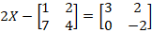 then X is equal to
 | a. | 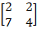 |  |  | b. |  | 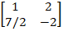
 | c. | 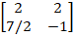 |  |  | d. |  | None of these
9. | Which one of the following is not true?
 | a. | Matrix addition is commutative |  |  | b. |  | Matrix addition is associative
 | c. | Matrix multiplication is commutative |  |  | d. |  | Matrix multiplication is associative
10. | 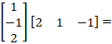 _______
 | a. | [-1] |  |  | b. |  | 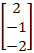
 | c. | 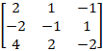 |  |  | d. |  | Not defined
11. | The function given by is
 | a. | Continuous & differentiable at x=1 |  |  | b. |  | Discontinuous but differentiable at x=1
 | c. | Continuous but not differentiable at x=1 |  |  | d. |  | Neither continuous nor differentiable at x=1
12. | If AB = C, the orders of matrices A, B, C are
 | a. |  |  |  | b.
 | c. |  |  |  | d.
13. | If then is equal to
 | a. | 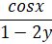 |  |  | b. |  | 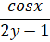
 | c. | 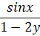 |  |  | d. |  | 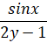
14. | The function defined by is discontinuous at:
 | a. | All rational points |  |  | b. |  | All irrational points
 | c. | All integral points |  |  | d. |  | None of the above
15. | If then is equal to:
 | a. |  |  |  | b.
 | c. |  |  |  | d.
16. | The conditions are called
 | a. | Restrictions only |  |  | b. |  | Negative restrictions
 | c. | Non-Negative restrictions |  |  | d. |  | None of the above
17. | The function is:
 | a. | Continuous everywhere but not differentiable at x = 0 |  |  | b. |  | Continuous & differentiable everywhere
 | c. | Not continuous at x=0 |  |  | d. |  | None of the above
18. | The differential coefficient of w.r.t ‘x’ is
 | a. |  |  |  | b.
 | c. |  |  |  | d.
19. | The absolute minimum value of is
 | a. | 0 |  |  | b. |  | -2
 | c. | 2 |  |  | d. |  | 1
20. | The function f(x) = tan x- x
 | a. | Always increases |  |  | b. |  | Always decreases
 | c. | Never increases |  |  | d. |  | Sometimes increases & sometimes decreases
Section B
In this section, attempt any 16 questions out of the questions 21 – 40.
Each Question is of 1 mark weightage
21. | If are 2 functions from defined as then for x<0 is
 | a. | 4x |  |  | b. |  | 2x
 | c. | 0 |  |  | d. |  | -4x
22. | The maximum value of slope of the curve is
 | a. | 0 |  |  | b. |  | 12
 | c. | 16 |  |  | d. |  | 32
23. | If 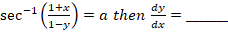
 | a. | 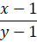 |  |  | b. |  | 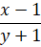
 | c. | 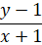 |  |  | d. |  | 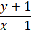
24. | If 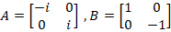 and then ‘a’ is equal to
 | a. | 1 |  |  | b. |  | -1
 | c. | -i |  |  | d. |  | i
25. | The curves
 | a. | touch each other |  |  | b. |  | cut at right angle
 | c. | cut at an angle |  |  | d. |  | cut at an angle
26. | The function is strictly
 | a. | increasing in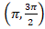 |  |  | b. |  | decreasing in 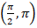
 | c. | decreasing in |  |  | d. |  | decreasing in  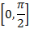
27. | The function has a stationary point at:
 | a. | x = e |  |  | b. |  | x =
 | c. | x = 1 |  |  | d. |  | x =
28. | Corner points of the feasible region for an LPP are (0,2), (3,0), (6,0), (6,8) and (0,5).  Let F = 4x + 6y be the objective function. The minimum value of F occurs at
 | a. | (0,2) only |  |  | b. |  | (3,0) only
 | c. | The midpoint on the line segment joining the points (0,2) & (3,0) only |  |  | d. |  | Any point on the line segment joining the points (0,2) and (3,0)
29. | For real numbers x and y, define xRy iff is an irrational number. Then the relation R is
 | a. | Reflexive |  |  | b. |  | Symmetric
 | c. | Transitive |  |  | d. |  | None of these
30. | Let 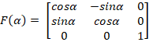, where is equal to
 | a. |  |  |  | b.
 | c. |  |  |  | d. |  | None of these
31. | If is equal to
 | a. | 0 |  |  | b. |  | 1
 | c. | 2 |  |  | d. |  | 3
32. | If 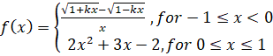  is continuous at x= 0, then k is equal to:
 | a. | -4 |  |  | b. |  | -3
 | c. | -2 |  |  | d. |  | -1
33. | If 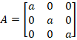 then the value of is
 | a. | a³ |  |  | b. |  | a⁶
 | c. | a⁹ |  |  | d. |  | a²³
34. | If 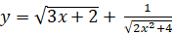 , then is equal to:
 | a. | 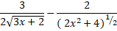 |  |  | b. |  | 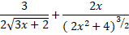
 | c. | 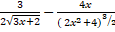 |  |  | d. |  | None of these
35. | The derivative of with respect to is:
 | a. | 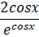 |  |  | b. |  | 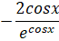
 | c. | 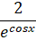 |  |  | d. |  | None of these
36. | If , then the value of in terms of y
 | a. |  |  |  | b.
 | c. |  |  |  | d. |  | None of these
37. | Let A be an invertible matrix. Which of the following is not true?
 | a. |  |  |  | b.
 | c. |  |  |  | d.
38. | If 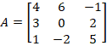 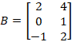 & 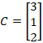 then the expression which is not defined is
 | a. |  |  |  | b.
 | c. |  |  |  | d. |  | AB
39. | The value of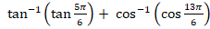 is
 | a. | 0 |  |  | b.
 | c. |  |  |  | d.
40. | The value of 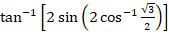 is
 | a. |  |  |  | b.
 | c. |  |  |  | d.
Section C
In this section, attempt any 8 questions out of the questions.
Each Question is of 1 mark weightage.
Questions 46- 50 are based on case study
41. | If 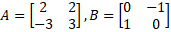 then =
 | a. | 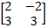 |  |  | b. |  | 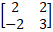
 | c. | 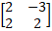 |  |  | d. |  | 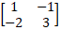
42. | If then is equal to:
 | a. | 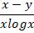 |  |  | b. |  | 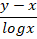
 | c. | 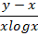 |  |  | d. |  | 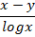
43. | The domain of the function is
 | a. | [0,1] |  |  | b. |  | [-1,1]
 | c. | (-1,1) |  |  | d. |  | [0,
44. | 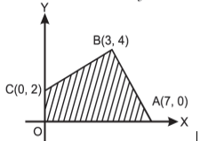 |  | The feasible region for an LPP is shown in the figure. Then the maximum value of Z= 5x + 7y
 | a. | 47 |  |  | b. |  | 43
 | c. | 45 |  |  | d. |  | 49
45. | Let be defined by 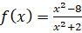 then ‘f’ is
 | a. | One-one but not onto |  |  | b. |  | One- one & onto
 | c. | Onto but not one-one |  |  | d. |  | Neither one-one nor onto
 | CASE STUDY
 | A man has a square shape piece of golden board of size 24 cm which is to be made into a box without top by cutting from each corner and folding the flaps to form a box.  Use the figure given to answer the following questions: |  |  |  |  | 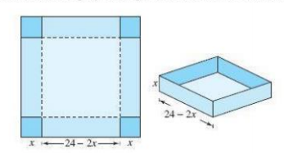
46. | Volume of the open box formed by folding up the flap is given by
 | a.
 | b.
 | c.
 | d.
47. | In the first derivative test, if changes its sign from positive to negative as x increases through C₁ then function attains
 | a. | Local maxima at x = C₁
 | b. | Local minima at x = C₁
 | c. | Neither maxima nor minima at x = C₁
 | d. | None of these
48. | What should be the side of the square piece to be cut from each corner of the board to hold maximum volume?
 | a. | 14cm
 | b. | 12cm
 | c. | 4cm
 | d. | 5cm
49. | What should be the maximum volume of open box ?
 | a. | 1034
 | b. | 1024
 | c. | 1204
 | d. | 4021
50. | The cost of the box if the rate of making the box is Rs 5 per cm, when the volume is maximum is
 | a. | Rs 2560
 | b. | Rs 2840
 | c. | Rs 3840
 | d. | Rs 2040

***

